Practical No. 5

Name : Danish Altaf Solkar Class : CO - B
Enrolment no. : 24111590805 Batch : 2

Aim : Write Use – cases and Draw Use – case diagram

1. Aim
To identify the actors and use-cases of a Smart Education Platform, write suitable use-case descriptions, and construct a UML Use Case Diagram.

2. Problem Statement
Design a use-case model for a Smart Education Platform. The system enables learners to register and log in, browse and search courses, enroll in courses, access learning materials, attempt quizzes, submit assignments, track learning progress and view performance. Instructors manage courses, learning materials, quizzes and assignments, while the administrator manages users, courses and reports. An external Notification Service sends system notifications, and a Payment Gateway processes online payments for paid courses.

3. Objectives
- Identify actors that interact with the software system.
- Identify the major functions (use-cases) provided by the system.
- Write simple descriptions for the identified use-cases.
- Understand association, include and extend relationships.
- Construct a Use Case Diagram using UML notation.

4. Actors
Actor | Description
Learner | Registers, browses courses, enrolls, accesses learning materials, attempts quizzes, submits assignments and tracks progress.
Instructor | Manages courses, learning materials, quizzes and assignments, and views learner performance.
Administrator | Manages users, courses and system reports.
Notification Service | Sends notifications and updates to learners and instructors.
Payment Gateway | Processes and confirms online payments.

5. Identified Use-Cases
Actor | Use-Cases
Learner | Register / Login; Browse Courses; Search Courses; Enroll in Course; Access Learning Materials; Attempt Quiz; Submit Assignment; Track Progress; View Performance; View Course History
Instructor | Manage Courses; Manage Learning Materials; Manage Quizzes; Manage Assignments; View Learner Performance
Administrator | Manage Users; Manage Courses; View Reports
Notification Service | Send Notifications
Payment Gateway | Process Payment; Confirm Payment

6. Use-Case Descriptions
Use-Case 1: Register / Login
Actor: Learner
1. Learner enters registration details or login credentials.
2. System validates the information.
3. System creates the account or grants access to the learner.
Use-Case 2: Browse Courses
Actor: Learner
1. Learner selects a course category or searches for a course.
2. System displays available courses.
3. Learner views the required course details.
Use-Case 3: Enroll in Course
Actors: Learner, Payment Gateway
1. Learner selects a course.
2. System checks enrollment and course availability.
3. If payment is required, the system sends a payment request to the Payment Gateway.
4. System creates the enrollment after successful payment, where applicable.
Use-Case 4: Attempt Quiz
Actor: Learner
1. Learner selects an available quiz.
2. System displays the quiz questions.
3. Learner submits answers.
4. System evaluates the quiz and updates learner performance.
Use-Case 5: Manage Course
Actor: Instructor
1. Instructor creates or selects a course.
2. Instructor adds or updates course information and learning materials.
3. System saves the changes and makes the course available to learners.
Use-Case 6: View Reports
Actor: Administrator
1. Administrator selects the required report.
2. System retrieves relevant user, course or performance data.
3. System displays the report.
Use-Case 7: Send Notifications
Actor: Notification Service
1. System generates a notification event.
2. Notification Service receives the notification request.
3. Notification Service sends the notification to the relevant user.

7. Use Case Diagram
The following model shows the actors and use-cases within the Smart Education Platform system boundary. The table identifies the associations between actors and system functions.

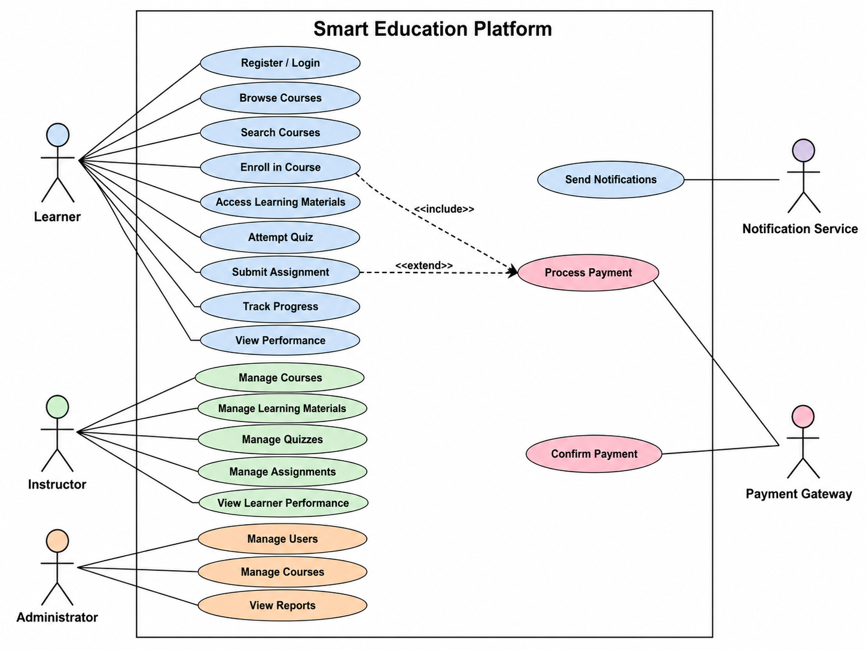

8. UML Relationships Used
Relationship | Meaning | Example
Association | Shows interaction between an actor and a use-case. | Learner → Enroll in Course
<<include>> | The included use-case is required as part of the main use-case. | Enroll in Paid Course → Process Payment
<<extend>> | Represents optional or additional behavior. | Enroll in Course ← Apply Coupon (optional, if supported)

9. Conclusion
The Smart Education Platform was analyzed to identify its external actors and major system functions. Suitable use-cases were written for the Learner, Instructor, Administrator, Notification Service and Payment Gateway. A use-case model was organized to represent interactions between the actors and the system. The practical demonstrates how use-case modeling can be used to understand and represent software requirements clearly.

